Latest Round-ups:
Season 2019/20
#13
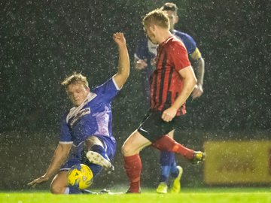
Midweek Action: Street rebounded from three consecutive defeats with a thumping 9-2 win at home to Bridport on Tuesday night. The hosts were utterly dominant at the Tannery, with Jakob Dickens and Patrick O’Halloran each striking before the break, adding to a first-half double from Leighton Thomas. The scoring continued during the second period, with Thomas completing his hat-trick, and further goals coming from Ollie Pearson, Kameron Andrews and Oliver Hebbard. Elsewhere in the Premier Division, Aron Robbins first half strike helped Hallen defeat Odd Down 1-0, while goals after the interval from Adey Harvey and Stefan Lee led Keynsham to a 2-0 win away at Chipping Sodbury Town. It was a case of instant déjà vu for Cadbury Heath, who conceded a late equaliser for the second time in three days to draw 1-1 away at Shepton Mallet. Just as he had done on Saturday against Wellington, Enis Akgun had put the Heath in position to claim an away victory, but they came unstuck in stoppage time once again, with Asa White heading home Shepton’s last gasp leveller. 10-man Brislington beat Cribbs 1-0 to register their third win in the space of ten days. The home side were up against it to back-up Saturday’s win when Tristan Plummer was awarded an early red-card, but after fellow forward Neikell Plummer had put Brislington ahead, the back five kept their visitors at bay to claim all three points. The following evening, Bradford Town held off the challenge of Bitton to win 2-1 at Trowbridge Road. After Matt Morris powered the hosts ahead after half-an-hour, Will Hailston tapped home to double their advantage a couple of minutes later. Bitton trimmed the deficit during a tense second-half, but the Bobcats held on to register another home victory. In Wednesday’s Devon derby, Exmouth produced a thrilling fightback to defeat Tavistock 4-2 at the King George V Ground. After falling behind in first-half stoppage time, Exmouth levelled affairs early in the second half through Ace High, before the visitors struck again to retake the lead. Having fallen 2-1 behind, Town made a concerted effort to hit back, and did so in fine fashion, with High and Callum Shipton scoring in a five-minute spell to turn the game on its head. With an exemplary home record to defend, Exmouth made sure of the three points late on, with Jordan Harris saving the best for last, scoring directly from a free-kick to wrap up all three points.
Action from Exmouth’s midweek victory over Tavistock, courtesy of Dave Crawford.
Bridgwater’s excellent form away from home continued in Wiltshire, where they came from behind to beat Westbury 2-1. Following a goalless opening half, Ryan Bole handed the home side a 57th minute lead when his corner sailed directly into the back of the Bridgwater net. The visitors responded in kind, scoring from a couple of corners of their own, with Tom Ellis thumping them level on the hour mark, before Jake Brown reacted fastest to a loose ball to score the winning goal 20 minutes from time.
Cheddar fought back from two goals down to claim a 2-2 draw away at Wells City on Tuesday evening in the First Division. The home side made a flying start to the game, with some excellent build-up play giving Harry Foster a one-on-one with the keeper which he finished with aplomb to open the scoring. Dale Hunt then doubled Wells’ advantage, before Adam Jones headed home a Sam King cross just before half-time to give the visitors a foothold in the contest. Cheddar pushed hard for an equaliser during the second half and it eventually came, with a defensive error capitalised upon by Adam Wright who claimed his ninth league goal of the season. On Wednesday, Warminster struck five second-half goals to claim a 5-1 win away at Bishops Lydeard who ended the game with nine-men. A 12th minute goal from Ali Bradley saw Devizes move on to the second round of the Wiltshire Senior Cup, thanks to a 1-0 win at home to Purton.
Premier Division: In a heavily reduced Saturday schedule, table topping Bradford Town produced a Leicester-esque performance away at Bridport, storming to a 9-0 victory. In a game that was one-sided from first minute to last, both Matt Morris and Lewis Powell scored first-half hat-tricks for the Bobcats who led by seven at the break. Powell added a second half header to take his personal tally for the afternoon to four, with Tyson Pollard and Charlie Maddison also getting on the scoring action at St Mary’s Field. Harry Horton was the saviour for Bridgwater, scoring twice in the final five minutes to salvage a 3-3 draw at home to Buckland. Town led by one goal to nil at the break thanks to a cross-come-shot from Jake Brown, before the visitors hit back four minutes into the second half via to a Richard Groves spot kick. Groves has had an excellent ten days for the Bucks, scoring in both of their previous victories, and he was clearly in the mood at Fairfax Park, putting his side ahead with a well-hit free kick, before then completing his hat-trick 20 minutes from time with a goal from open play. The Devonians looked destined to make it nine points from nine, but Horton had other ideas, setting up a thrilling ending when he buried a long-range half volley four minutes from time. Horton then repeated the trick three minutes later, volleying home Bridgwater’s equaliser with his left foot to bring the curtain down on an entertaining affair. In Bath, goals at either end of the game from Zach Drew and Syd Camper handed Clevedon Town a 2-0 victory over Odd Down who remain without a league win in over two months.

First Division: Wincanton Town moved into a share of top spot thanks to a hardly-fought 1-0 victory away at Warminster. Coming off the back of a big midweek win, expectations were high for Warminster, but they fell to defeat, with the solitary coming midway through the first half from Toby Dolton Cole. In another game which survived the weather, the points were shared at Bowdens Park, where Cheddar drew 1-1 with Welton Rovers. It was Rovers who took the lead after half an hour, with Harry Barter scoring his first goal for the club following some good build-up play from the visiting forward line. The Cheesemen weren’t behind for long however, and ended up securing a point thanks to Adam Wright’s successful penalty kick, following a foul on Callum Ham in the visitors area. Ashton & Backwell United are now up to third, holding off a spirited fightback from Bristol Telephones before eventually claiming a 3-2 win. In tough conditions, the away side had two goals from George Jones, and a Sam Thomas effort to thank for putting them three goals to the good. The Phones then struck twice to trim the deficit, but Ashton held on to stretch their unbeaten run to seven matches in all competitions. Lebeq United have now won four of their previous five league games following a 3-0 triumph at home to Corsham Town. Cameron Brown was the difference between the two sides during the first half, scoring twice, before Lebeq added a third in stoppage time to climb up to seventh in the league table.
Both images below are from Lebeq’s 3-0 victory, courtesy of John Cuthbertson.
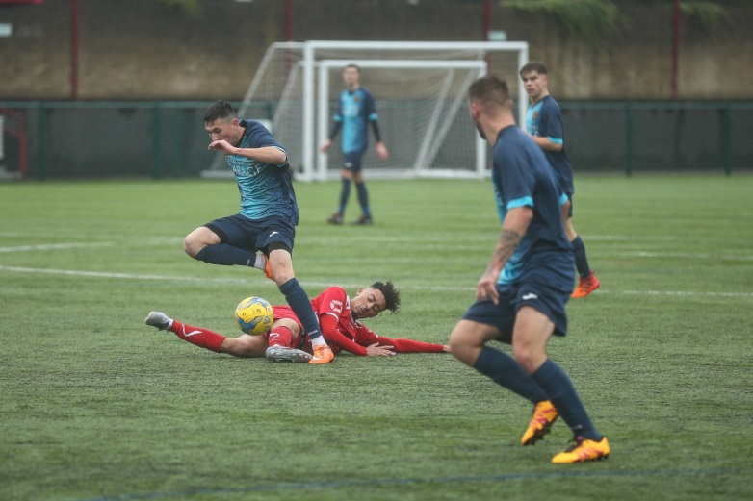
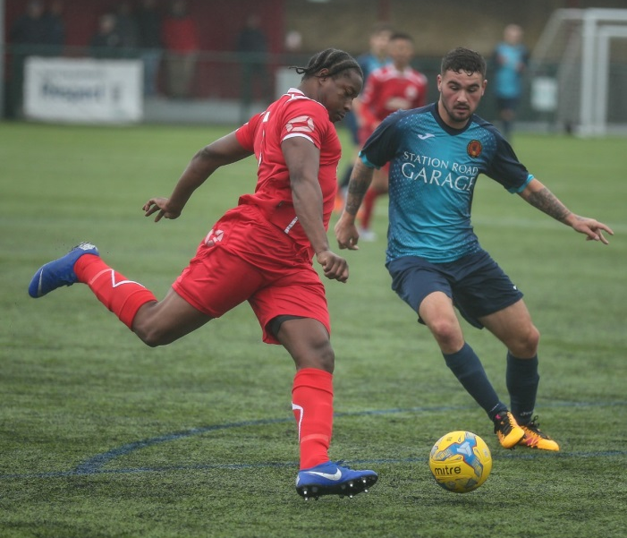

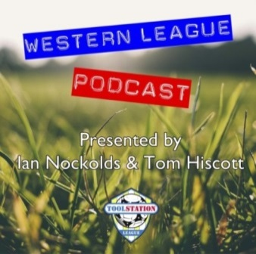

Be sure to check out the latest podcast, where Ian, Tom & guests recap all the latest news and results from around the Western League. To follow along all season, each broadcast will be available at the following link: http://www.toolstationleague.com/podcasts.php

Western League Statistical Leaders

PREMIER DIVISION LEADING GOAL SCORERS (League only):
Adam Carter (Plymouth Parkway) – 17
Jack Taylor (Bridgwater Town) – 9
Jack Fillingham (Shepton Mallet) – 9
Lucas Vowles (Clevedon Town) – 9
Josh Egan (Bitton) – 9
Gary Higdon (Bradford Town) – 9

PREMIER DIVISION TOP ATTENDANCES:
Bridport 0 Bridgwater Town 6, Sunday 6th October 2019 – 347
Wellington 0 Exmouth Town 2, Sunday 6th October 2019 - 315
Plymouth Parkway 1 Exmouth Town 0, Wednesday 21st August 2019 - 308

FIRST DIVISION LEADING GOAL SCORERS (League only):
James Rustell (Radstock Town) – 14
Harry Foster (Wells City) – 11
Stuart Windsor (Calne Town) – 10
Adam Wright (Cheddar) – 10
Danny Carter (Longwell Green Sports) - 10

FIRST DIVISION TOP ATTENDANCES:
Warminster Town 2 Bristol Telephones 3, Saturday 5th October - 369
Portishead Town 3 Longwell Green Sports 5, Saturday 5th October – 262
Devizes Town 0 Ashton & Backwell United 1, Saturday 5th October – 252

LEADING SCORERS IN ALL COMPETITIONS:
Jack Crago (Tavistock) - 20
James Rustell (Radstock Town) – 19
Adam Carter (Plymouth Parkway) – 17
Harry Foster (Wells City) – 14
Gary Higdon (Bradford Town) – 13
Jack Taylor (Bridgwater Town) - 12
Jack Fillingham (Shepton Mallet) – 12

*All goalscoring stats via
Full-Time FA website
Latest Results
Tuesday 22nd October 2019
Premier Division
Brislington 1-0 Cribbs 86
Chipping Sodbury Town 0-2 Keynsham Town
Hallen 1-0 Odd Down 48
Shepton Mallet 1-1 Cadbury Heath 86
Street 9-2 Bridport 95
First Division
Wells City 2-2 Cheddar 100
Wiltshire FA Senior Cup – First Round
Devizes Town 1-0 Purton
Wednesday 23rd October 2019
Premier Division
Bradford Town 2-1 Bitton 124
Exmouth Town 4-2 Tavistock 174
Westbury United 1-2 Bridgwater Town 55
First Division
Bishops Lydeard 1-5 Warminster Town
Saturday 26th October 2019
Premier Division
Bridgwater Town 3-3 Buckland Athletic 189
Bridport 0-9 Bradford Town 90
Odd Down 0-2 Clevedon Town 51
First Division
Bristol Telephones 2-3 Ashton & Backwell United 73
Cheddar 1-1 Welton Rovers 60
Lebeq United 3-0 Corsham Town 56
Warminster Town 0-1 Wincanton Town 128

Upcoming Fixtures
Tuesday 29th October 2019
Premier Division
Shepton Mallet vs Exmouth Town 19:30KO
Les Phillips Cup – First Round
Ashton & Backwell United vs Bitton 19:30KO
Brislington vs Bradford Town 19:30KO
Buckland Athletic vs Cheddar 19:30KO
Cribbs vs Welton Rovers 19:45KO
Devizes Town vs Hallen 19:30KO
Radstock Town vs Street 19:30KO

Wednesday 23rd October 2019
Les Phillips Cup – First Round
Bishops Lydeard vs Keynsham Town 19:30KO
Bridgwater Town vs Odd Down 19:45KO
Clevedon Town vs Chipping Sodbury Town 19:30KO
Corsham Town vs Wells City 19:45KO
Exmouth Town vs Plymouth Parkway 19:30KO
Hengrove Athletic vs Shepton Mallet 19:30KO
Roman Glass St George vs Bridport 19:30KO
Tavistock vs Calne Town 19:30KO
Warminster Town vs Portishead Town 19:45KO
Westbury United vs Longwell Green Sports 19:30KO

Saturday 2nd November 2019 (KICK OFF AT 3.00PM UNLESS NOTED)
FA Vase – Second Round
AFC St Austell vs Buckland Athletic
Baffins Milton Rovers vs Bradford Town
Bitton vs Fairford Town
Brockenhurst vs Plymouth Parkway
Petersfield Town vs Roman Glass St George
Saltash United vs Bridgwater Town
Tavistock vs Exmouth Town
Thornbury vs Cribbs
Warminster Town vs AFC Portchester
Premier Division
Chipping Sodbury Town vs Cadbury Heath
Hallen vs Brislington
Keynsham Town vs Westbury United
Odd Down vs Bridport
Shepton Mallet vs Wellington
Street vs Clevedon Town
First Division
Bishops Lydeard vs Devizes Town
Calne Town vs Bristol Telephones
Corsham Town vs Hengrove Athletic
Longwell Green Sports vs Wells City
Oldland Abbotonians vs Bishop Sutton
Radstock Town vs Portishead Town
Sherborne Town vs Lebeq United
Welton Rovers vs Ashton & Backwell United
Wincanton Town vs Almondsbury

League Tables
Premier Division
 |  | P | W | D | L | F | A | GD | PTS
1 | Bradford Town | 12 | 10 | 1 | 1 | 39 | 13 | 26 | 31
2 | Plymouth Parkway | 10 | 8 | 1 | 1 | 43 | 8 | 35 | 25
3 | Bridgwater Town | 12 | 7 | 3 | 2 | 39 | 18 | 21 | 24
4 | Exmouth Town | 9 | 7 | 0 | 2 | 22 | 5 | 17 | 21
5 | Brislington | 14 | 7 | 0 | 7 | 23 | 33 | -10 | 21
6 | Hallen | 12 | 6 | 2 | 4 | 22 | 24 | -2 | 20
7 | Clevedon Town | 12 | 6 | 1 | 5 | 25 | 27 | -2 | 19
8 | Bitton | 10 | 6 | 0 | 4 | 29 | 16 | 13 | 18
9 | Street | 12 | 6 | 0 | 6 | 30 | 27 | 3 | 18
10 | Westbury United | 11 | 5 | 2 | 4 | 21 | 18 | 3 | 17
11 | Buckland Athletic | 11 | 5 | 1 | 5 | 20 | 21 | -1 | 16
12 | Shepton Mallet | 9 | 4 | 2 | 3 | 19 | 15 | 4 | 14
13 | Keynsham Town | 10 | 4 | 2 | 4 | 21 | 22 | -1 | 14
14 | Cadbury Heath | 13 | 3 | 5 | 5 | 18 | 26 | -8 | 14
15 | Cribbs | 13 | 4 | 2 | 7 | 16 | 30 | -14 | 14
16 | Roman Glass St George | 9 | 4 | 0 | 5 | 25 | 12 | 13 | 12
17 | Tavistock | 8 | 3 | 2 | 3 | 19 | 16 | 3 | 11
18 | Wellington | 12 | 3 | 1 | 8 | 15 | 31 | -16 | 10
19 | Odd Down | 13 | 3 | 1 | 9 | 13 | 32 | -19 | 10
20 | Bridport | 15 | 3 | 1 | 11 | 21 | 55 | -34 | 10
21 | Chipping Sodbury Town | 13 | 2 | 1 | 10 | 13 | 44 | -31 | 7

First Division
 |  | P | W | D | L | F | A | GD | PTS
1 | Calne Town | 11 | 7 | 2 | 2 | 19 | 7 | 12 | 23
2 | Wincanton Town | 11 | 7 | 2 | 2 | 25 | 17 | 8 | 23
3 | Ashton & Backwell United | 11 | 6 | 4 | 1 | 19 | 14 | 5 | 22
4 | Wells City | 11 | 6 | 2 | 3 | 29 | 18 | 11 | 20
5 | Longwell Green Sports | 10 | 6 | 1 | 3 | 23 | 17 | 6 | 19
6 | Radstock Town | 10 | 6 | 0 | 4 | 25 | 20 | 5 | 18
7 | Lebeq United | 11 | 6 | 0 | 5 | 25 | 21 | 4 | 18
8 | Cheddar | 11 | 5 | 2 | 4 | 21 | 17 | 4 | 17
9 | Oldland Abbotonians | 11 | 4 | 4 | 3 | 10 | 13 | -3 | 16
10 | Corsham Town | 12 | 5 | 1 | 6 | 22 | 34 | -12 | 16
11 | Sherborne Town | 9 | 5 | 0 | 4 | 18 | 18 | 0 | 15
12 | Portishead Town | 9 | 4 | 1 | 4 | 24 | 20 | 4 | 13
13 | Bishops Lydeard | 10 | 4 | 1 | 5 | 20 | 19 | 1 | 13
14 | Almondsbury | 10 | 4 | 1 | 5 | 16 | 18 | -2 | 13
15 | Warminster Town | 11 | 4 | 0 | 7 | 23 | 18 | 5 | 12
16 | Welton Rovers | 11 | 3 | 2 | 6 | 13 | 22 | -9 | 11
17 | Devizes Town | 10 | 2 | 4 | 4 | 20 | 20 | 0 | 10
18 | Hengrove Athletic | 10 | 2 | 3 | 5 | 6 | 26 | -20 | 9
19 | Bishop Sutton | 10 | 2 | 1 | 7 | 13 | 19 | -6 | 7
20 | Bristol Telephones | 11 | 1 | 1 | 9 | 16 | 29 | -13 | 4

